Multi-text Study
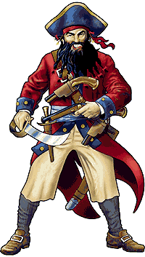
RE 4030

Miranda Bass
Spring 2007

The Not-So-Jolly Roger
by Jon Scieszka

Pirates by Brian Williams

Why I chose to have my students read The Not-So-Jolly Roger....
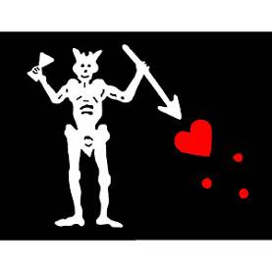
One of the reasons I chose the book, The Not-So-Jolly Roger by Jon Scieszka, is that I enjoy reading fiction books with adventure, and I felt my students would too. Using adventure, or fiction books, in the classroom is a great way to get students involved and excited about what they are reading. I feel safe to say that all children have read an adventure book or seen an adventurous movie before.
Blackbeard is one of the most famous pirates ever known and The Not-So-Jolly Roger helps students encounter some of his ways by reading through the text. This book takes students on a remarkable journey through the eyes of three young boys who find travel back in time when The Book sends them to look for buried treasure. Students will be drawn into reading this book immediately because the book catches the readers’ attention from page one.
Students will also have the chance to expand their knowledge about pirates through reading the informational text by Brian Williams called Pirates. This informational book shares the ups and downs of a pirate’s life at sea from meeting the pirate, to having a glossary of terms the students may encounter and need to know when studying pirates.
Another reason I chose The Not-So-Jolly Roger is Blackbeard is an important part of the NCSCS for fourth grade Social Studies. This novel shares with students who Blackbeard was and most importantly the type of person he appeared to be in the manor of using humor and adventure through three young boy’s eyes. Students will not only be amused with the lifestyle of Blackbeard but the lifestyle of pirates in general. Although this novel does use adventure to capture the reader’s attention, the book contains some factual information as to how Blackbeard would weave hemp through his hair and light it on fire during battle. This novel also contains information on vocabulary used during the pirate ages, facts about Blackbeard such as his ship’s name, and his real name. The informational text I chose along with this novel, Pirates contains many of the vocabulary terms used within the novel that I want students to know. This informational text can also be read by all the students because it is simply written and has illustrations that will capture the attention of young readers. The text is not overwhelming or too difficult for students to read but provides students with factual information.
My hope in choosing both of these text are for students to learn several fun facts about pirates, and more specifically, that they learn a little information about Blackbeard, the most feared pirate on the sea!

Texts:

Scieszka, Jon. The Not-So-Jolly Roger. New York: Puffin Books, 1993.
- Reading Level: 4th grade

Williams, Brian. Pirates. Milwaukee, Wisconsin: Gareth Stevens Publishing, 2005.
- Reading Level: 4th grade

North Carolina Language Arts Standard Course of Study:
Grade 4
Unit Activity | NC Language Arts Grade 4
Students define Tier 2 vocabulary with their student packet and complete various vocabulary. The student’s knowledge of the vocabulary words is assessed at the end of the unit using a multiple choice final vocabulary test. Students also examine the author’s craft by investigating similes and onomatopoeia within the novel, The Not-So-Jolly Roger. Then, students create an artistic representation of two similes found within the text in order to compare the two. During “Discussion Director” students create text based on discussion questions for their small groups. | - Increase reading and writing vocabulary through:  - wide reading  - word study  - knowledge of homophones, synonyms, antonyms, homonyms  - knowledge of multiple meanings of words  - writing process elements  - writing as a tool for learning  - seminars  - book clubs  - discussions  - examining the author's craft
Before, during and after reading students will complete a K-W-L. I will use this to assess what the students know before, want to know and learned from reading the texts. Students also interact with the text and make inferences and evaluations by perusing and browsing three different areas full of books and information on penguins, their habitat and life cycle. Students will use an Internet workshop to seek additional information about pirates. Students will also complete a learning log/response journal as a means of connecting the text to the student’s personal experiences. Students will create higher level thinking questions to ask classmates, complete with pages numbers in the text to support their answer. | - Interact with the text before, during, and after the reading, listening, and viewing by:  - setting a purpose using prior knowledge and text information  - making predictions  - formulating questions  - locating relevant information  - making connections with previous experiences, information, and ideas
Students will complete a character sketch that asks students to focus on implied character traits by looking at a character’s actions and words. Students will add to this throughout the entire text, and complete a visual to accompany the information. Students support their evidence of implied traits by the citing page numbers and passages on which they found the supporting evidence. | 3.02 Analyze characters, events, and plots within and between selections and cite supporting evidence.  3.03 Consider the ways, language and visuals, bring characters to life, enhance plot development, and produce a response.
Students develop a Reader’s Theatre presentation of sections from The Not-So-Jolly Roger. | 4.01 Read aloud grade-appropriate text with fluency, comprehension, expression, and personal style demonstrating an awareness of volume, pace, audience and purpose.
Students will write an “I Am” poem using a main character from The Not-So-Jolly Roger. Students will create a Reader’s Theatre script from a section of the novel and perform it in class. Students will write a feature news story about how the boy’s adventure started or another topic within the book they may find interesting. | 4.07 Compose a variety of fiction, non-fiction, poetry and drama using self-selected and assigned topics and forms.

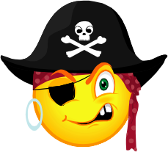
Additional Unit Books
Fiction:
Long, Melinda. How I Became a Pirate. New York, NY : Scholastic Inc., 2004

- This book is about a young boy who became a pirate. The boy soon finds out that pirates do whatever they want pretty much and one they he found out they didn’t do was tuck people in or read stories to them. The book goes along with The Not-So-Jolly Roger because there are some pirate vocabulary words we encounter throughout the book. This book has the term Jolly Roger throughout it just as our novel The Not-So-Jolly Roger has too.

Kimmel, Eric. Blackbeard’s Last Flight. New York: Farrar, Straus and Giroux., 2006.

- This book is about Lieutenant Robert Maynard and a young boy by the name of Jeremy Hobbs who set out to the coast of North Carolina to wipe out Blackbeard. The men wanted to make sure Blackbeard never gained control of the North American coastline and to do this they had to kill him. The illustrations are simply breathtaking throughout this book and capture the reader’s attention. This book is great since the novel we are reading is centered on Blackbeard himself. This book gives detail of how Blackbeard was killed although some of the facts are untrue causing this book to be a fiction book.

Thompson, Julie and Macintosh, Brownie. A Pirate’s Life for Me! . Watertown, MA; Charlesbridge, 1996.

- This book shares with the reader what a day may be like on a pirate ship. This book uses many of the vocabulary words we will be encountering throughout our novel, The Not-So-Jolly Roger. Students will enjoy reading about the different jobs performed on a pirate ship and the hard work pirates put into operating a ship. Although this book is not entirely factual, there is still great information throughout the book and lots of information the students will learn from reading the book.

Lightenheld, Tom. Eveything I Know About Pirates. New York, NY; Aladdin Paperbacks, 2000.

- This is a funny book students will enjoy reading. The book contains made up facts, and what is thought pirates were like. Students will see how the author has taken actual terms, and items dealing with pirates, to make them entertaining to modern day readers. This is a great book to go along with the Not-So-Jolly Roger because it keeps the readers attention while letting them have a laugh when reading about the pirates.

Non-Fiction:
Harward, Barnaby. The Best Book of Pirates. Boston, Massachusetts; Kingfisher 2002.

- This is a great source of factual events that take place during the time of pirates. The book is full of information from vocabulary to what pirates actually are. The book contains a lot of information we will be learning about throughout our multi-text study as well as from the novel we are reading, The Not-So-Jolly Roger.

Breverton,Terry. The Pirate Dictionary. Gertna, Louisiana; Pelican Publishing 2004.

- This book of pirate terms is a great informational source for students to look over while reading The Not-So-Jolly Roger because students can look up words they are unfamiliar with. This book contains many of the words the students will be learning throughout the multi-text unit.

Konstam, Angus. Pirates 1660-1730. New York, NY: Osprey Publishing., 1998.

- This informational book is full of facts students will enjoy reading about such as why pirates turned to a life of piracy and how they dressed. This book is appropriate to let students look over and read while we read our novel, The Not-So-Jolly Roger because this book helps the students paint a mental picture of how these pirates actually were.

Konstam, Angus. The History of Pirates. USA: The Lyons Press., 1999.

- This informational text is wonderful with all the maps and illustrations for students to look over. This book is appropriate for students to read over during the multi-text unit because this book contains a pirate profile on Edward Teach “Blackbeard.” Blackbeard is who our novel is focused on and so this is great for students to look over.

Poetry:
Jackson, Kathryn and Byron, Pirates, Ships, and Sailors. New York: Golden Books, 1950.

- This book of poems about pirates is great for students to read! The poems are humorous for students but also use vocabulary pertaining to pirates. This fits in great with our multi-text because students will use some of the same vocabulary words used throughout many of these poems.

Silverstein, Shel, Where the Sidewalk Ends. New York: Harper Collins Publishers, 2004.

- This book is full of poems and contains two poems about pirates. The poems contained in this book on pirates are comical and will surely make the students laugh. Although the poems are written to be funny many students will enjoy them because they are about pirates which we are focusing on throughout our multi-text.

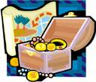

All the above listed books will be available for students to read on their own time for additional resources to expand the knowledge they have about pirates. Students will be able to connect the fictional books and poems to the non-fiction, informational texts. The Not-So-Jolly Roger contains information that is accurate about pirates as well as vocabulary students should be familiar with when studying pirates. Students will see how reading books can and will help them expand their knowledge while making connections to what we are studying. Students who view the books within the multi-text will have the chance to experience adventure, humor, and fascination while gaining new knowledge of the pirate lifestyle and pirate vocabulary. Students will embark on the wonderful journey of learning through the use of books! The treasure that awaits the students is the treasures of adventure and learning new information! Let the hunting begin for these treasures!

The Not-So-Jolly Roger
Literary Packet Outline

WEEK ONE
Before Reading: Day 1 (Small Group and Individual)

- “What I Noticed About These Areas” Activity
  - Students will view books, pictures, and articles related to: Pirates, Blackbeard, and vocabulary relating to pirates.
  - Students will complete a worksheet about what they noticed about these areas.
- K-W-L on pirates
- Read Pirates by Brian Williams in groups
- Predictions of Story Elements

Pg. 1-4 Day 2

- Discuss ABC Book Assignment (Whole Group)
- Begin Character Sketcher: Characterization (Individual)

Pg. 5-10 Day 3 (Small Group and Individually)

- Discussion Director (Small Group)
- Vocabulary Worksheet (Week 1)-Introduce and begin
- Vocabulary Assignment in packet, individually

Pg. 11-17 Day 4

- Double Entry Diary (Individual)
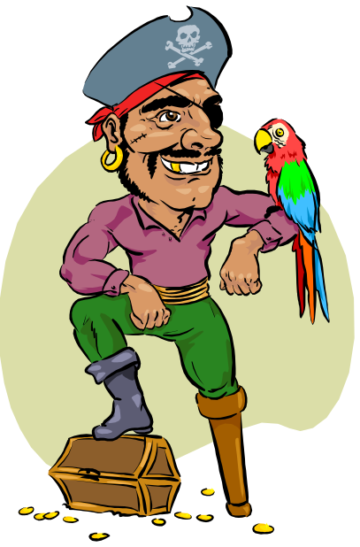
- Vocabulary Activity in packet (Individual)

Pg. 18-25 Day 5
- Author’s Craft (Whole Group)
- Artistic Representation (Individual)
- Begin Internet Workshop (Pairs)

WEEK TWO
Pg. 26-32 Day 6

- I Poem (Whole Group, then Individual)
- Vocabulary Worksheet (Week 2) and Activity in packet

Pg. 33-37 Day 7

- Feature Story (Pairs)
- Internet Workshop continued (Pairs)
- Vocabulary Activity in packet (Individual)

Pg. 38-45 Day 8

- Learning Log/ Response Journal (Individual)
- Vocabulary Activity in packet (Individual)

Pg. 46-51 Day 9

- Poems for Two Voices (Pairs)
- Reader’s Theater (Small Group)
- Wanted Poster (Individual)
- Vocabulary Activity in packet (Individual)

Pg. 52-57 Day 10

- Performance of Reader’s Theater, Poem for Two Voices and presentations of Wanted Posters
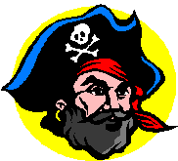

WEEK THREE
After Reading: Day 11-13 (Whole Group)

- Final Vocabulary Assessment
- Revisit Story Elements Predictions
- Completion of “L” (K-W-L)
- ABC Book

The Not-So-Jolly Roger
By Jon Scieszka

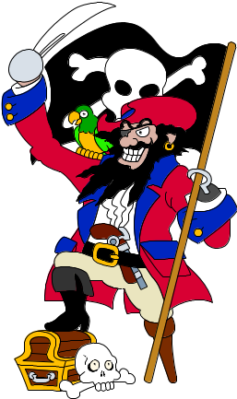

“It had strange silver writing on the front that said The Book.” Joe

“Black hair stuck out everywhere. His black eyebrows and moustache bristled out front. Long black strands fell down his back. And a monstrous black beard, with four pigtails, braided and tied with ribbons on the ends, fell down his chest. To top it all off---the whole mess was smoking!”

Name: ________________________________________

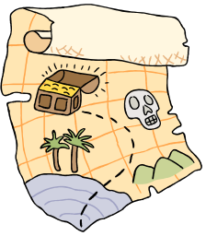
What I Noticed About
These Areas

AREA 1

AREA 2

AREA 3

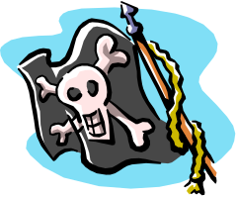
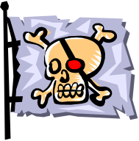
K-W-L

You will be completing a K-W-L on pirates. Think about what you know, what you want to know, and finally what you have learned. Use the following words to help you come up with questions you would like answered for the “W” column.
WHO, WHAT, WHERE, WHEN, WHY, & HOW
K  What I Think I KNOW | W  What I WANT To Know | L  What I LEARNED

After reading Pirates by Brian Williams and gaining an understanding of your topic, go back to the “K” column and see if any of the ideas you ‘”thought you knew” were inaccurate. Check any of them that are inaccurate, according to the text. Rewrite any of your statements that were inaccurate so that they are correct. Then go to the “L” column and begin grouping or categorizing what you have learned.

Before You Read: Look carefully at the front and back covers of The Not-So-Jolly Roger. Write down your predictions about the following:
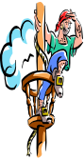

Setting (Time and Place): When and Where do you think this book takes place?

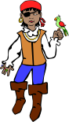Characters (The people, animals, or objects around which the action of the story is centered): Who do you believe the main characters in the book will be?

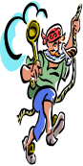 Problem(s) & Solution(s) (What goes wrong in the story and how is it solved?): What do you predict will be the most significant problems in this book? How do you believe the problems may be solved? ______

Write down any other questions or predictions:

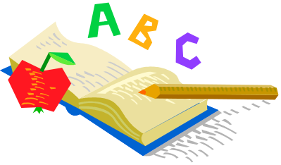
BOOK
Choose 1 or 2 items from the chart below to create pages for an alphabet book for all to share. Each page should include a large capital letter, an illustration or some artistic impression, and a paragraph (at least 5 sentences) explaining your letter representation. Design your page with an interesting format and type font. Your page should be vertical. The following are examples you may use but are not limited to:

A  Aye Aye  awful |  | B  Book  beach  Blackbeard  barnacles | C  cap  coconut  cannons  cutlass |  | D  drunken  Disney  doubloon | E  equipped  Edward Teach
F  Fred  flag  focus  face down |  | G  glasses  giant  guys | H  halt  heave ho  hands |  | I  island | J  Joe  jagged
K  kicked  knock |  | L  lads  lifted | M  magic  monstrous  meanest |  | N  nastiest  New York  North Carolina | O  ocean  once  open
P  parrot  pirates  pistols  plank | Q  quick  Queen Anne’s Revenge |  | R  rowboat  ragged  ransom  rum  Royal Pardon | S  Sam  sun  sailing  ship |  | T  treasure  tree
U  ugliest | V  voice |  | W  waves  writing  wish  siXteen | Y  Yo Ho Yo Ho  Z  zinged

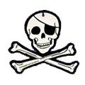
Character Sketcher

Your job as Character Sketcher is to identify a character’s actions (traits) and explain or prove these traits, identify the character’s goal (which is what the character wants to do or accomplish), identify the problem and solution in the reading, and complete a sketch or illustration of the character.

You need to be aware that the character traits you will choose will be implied character traits. In other words, they are not directly stated in the passage. You really want to use descriptive words for your character traits. You do not want to use words like good, bad, nice, and mean. Be sure to use your “Descriptive Character Traits” page for help.

Sometimes the solution to your character’s problem will not be in the section of the book that you are reading. In this case, you will need to come up with a possible solution for your character’s problem. When you begin artistically representing your character, try to use any physical descriptions from the text to help you. Your “artistic impression” of the character will probably be on a separate piece of paper. The next page gives you an example of how your paper may look with the character information.

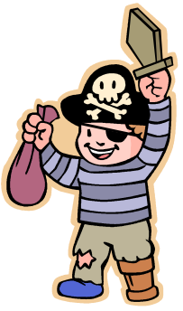
Character’s Name_______________________

Section and title of book you are reading: ______________________

Implied Character Traits (3)

- (trait) _________________ p.______ par.________
(explanation or proof of trait)

_____________________________________________________________________

_____________________________________________________________________

- (trait) __________________p.______par._________
(explanation or proof of trait)
___________________________________________________
___________________________________________________

- (trait) __________________p.______par._________
(explanation or proof of trait)
___________________________________________________
___________________________________________________

Character’s Goal:
_______________’s goal is to
___________________________________________________.
Problem:
_______________’s problem is
___________________________________________________.
Solution or Possible Solution: _____________________________
___________________________________________________.

Discussion Director
The Not-So-Jolly Roger

- Your job is to involve the students in your group by thinking and talking about the section of the book you have just read. You are going to ask questions that really help the students in your group think about the reading. Your questions should require students to discuss their interpretations of the text and connect background experience and knowledge with the text. You want all students involved in the discussion and talking about issues that come up during the reading.

- Your job as the Discussion Director is to come up with 5 thinking questions. Your teacher really wants you to help the students in your group to go back to the book to find their answers, if they don’t know them. So, to help this run very smoothly, you need to write down the questions, your answers to your questions, and the page numbers where the students can reference the text to justify their responses to your questions.

- When developing your questions, think about the young boys and how their adventure began, maybe how they could reverse the wish they made, their encounter with Blackbeard, what the thoughts of the young boys are throughout the book, Blackbeard’s personality, Blackbeard’s looks, or even the crew on the Queen Anne’s Revenge.

- Remember your questions need to be high dollar questions or what we talked about as “thick juicy” questions; stay away from the cheap questions and the skinny ones!

Vocabulary


You will complete the following chart with child-friendly definitions for these words. Then, you are invited to complete a set of daily vocabulary activities to go with these words.

Word | Meaning
brilliant
p. 8

monstrous
p. 13

horribly
p. 14

muttered
p. 21

otherwise
p. 22

Vocabulary Activities
WEEK 1
Word Networks
- What people, things, situations, or words come to mind when you think about the word monstrous?

Monstrous

Synonyms and Antonyms

Synonym | Word | Antonym
 | brilliant
 | horribly
 | otherwise
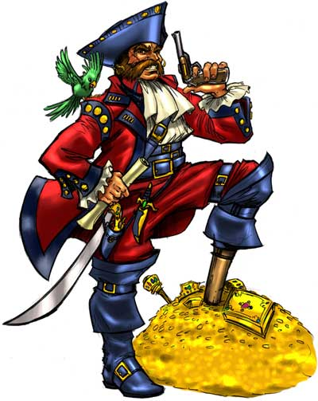

Sentence Stems/Idea Completions
- The student muttered to himself because _______________
_____________________________________________________.

- The birthday party was wonderful, otherwise_____________
_____________________________________________________.

Double Entry Diary

You are invited to complete a Double-Entry Diary for this section of the book. Remember to write down the quotation or passage and the page number on the left side of your paper. On the right side of your paper, write your response or personal reactions and connections to what was written in the left column.
Here’s an example to start with:
Quotation/Passage  and page number  “’We’re lost,’ moaned Sam. ‘Shipwrecked. Castaways. Robinson Crusoe’s in time and space. We have no idea where or when we are. Aaaaaaaaaaah!!!” Page 2 | Your response, reactions, and connections to the quotation or passage.  This passage brought back memories of when I got lost as a younger child from my parents. I always panicked because I had this overwhelming fear of never getting back to my normal everyday life with my parents. Just as Sam in the story began to panic when he was in an unfamiliar place, I was very similar as a child. I would often walk away from my parents when we were in a store or outside at a park to go play and then when I would look my parents were no where in sight. This section brings me to those feelings I used to get of never seeing my parents again.
Double Entry Diary
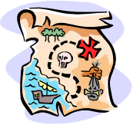

Now, it’s your turn… Go for it!

Quotation/Passage  and page number | Your response, reactions, and connections to the quotation or passage.

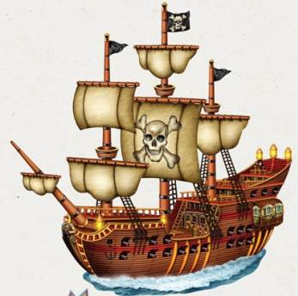
Internet Workshop
for The Not-So-Jolly Roger
This internet workshop will introduce you to Pirates. You will have an opportunity to explore information on the Internet. Take notes in your Journal. Come prepared to share your information at our workshop session. We will discuss possible ways of presenting your information (Inspirations, PowerPoint, Poster, Graphic Organizer, What Am I Poem, Who Am I Poem, or I Poem). http://www.graphic.org/index.html.
Please complete the following workshop. See rubric for presentation information:
Read about Pirates and Blackbeard particularly by clicking on the links below:
http://www.surfnetkids.com/pirates.htm
http://blindkat.hegewisch.net/pirates/diff.html
http://www.geographia.com/bahamas/blackbeard.htm
Then, answer the following questions in your journal:
- According to the websites, what is the definition for a pirate?
- What are the differences between a privateer and a buccaneer?
- What is Blackbeards’ real name?
Next you will click on the following website to learn about Blackbeard’s life at sea.
http://www.nationalgeographic.com/pirates/bbeard.html
http://historicbeaufort.com/ship.html
Please answer the following questions in your journal:
- What did Blackbeard stuff under his hat to make himself appear to be more ferocious and menacing?
- According to a website above, what did Blackbeard rename his ship?
Now click, http://www.theworksoftimpowers.com/graphics/blackbeard.jpg, and view a photograph of Blackbeard himself!
Please describe your feelings after viewing his picture. What fascinated you about this famous pirate? What did you learn from the picture?
Are there any facts you have read today that were also found in The Not-So-Jolly Roger? Please share these facts!


Author’s Craft

Jon Scieszka chooses his words very carefully, making use of several interesting literary devices. They appeal to the reader’s senses and sense of humor by using such figurative language. Find two examples of each listed below. Then explain how each passage adds meaning to the story.

 | Page number/  Example/  What does this passage add to the story? | Page number/  Example/  What does this passage add to the story?
Onomatopoeia : a word(s) that imitates the sound it represents
“Blackbeard drove the point of his cutlass into the deck with a loud thunk.”
Page 28
Simile: a comparison that includes the words like or as
“And they never take anything useful with them—like a machine gun or a jet.”
Page 6

ARTISTIC REPRESENTATION
Now that you have chosen two examples of similes, please artistically represent one of these comparisons. You may use any artistic medium. The following are options: colored pencils, markers, crayons, watercolors, pastels, collage, etc. Use your creativity!!!!

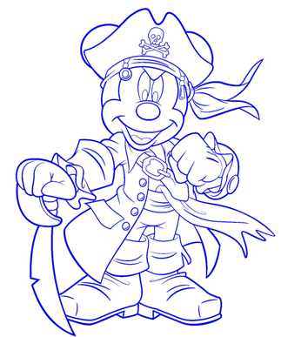
Vocabulary


You will complete the following chart with child-friendly definitions for these words. Then, you are invited to complete a set of daily vocabulary activities to go with these words.

Word | Meaning
staggered
p. 23

ransom
p. 27

murmured
p. 29

groaning
p.37

stunned
p. 52

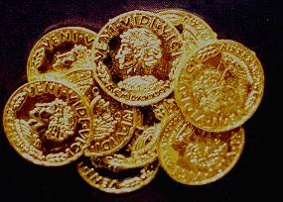
Vocabulary Activities
Week 2
Questions, Reasons, Examples
- If you were trying not to be stunned, you might NOT act in what manner?

Making Choices
- Which of the following could be best described as a “groan?” Circle your answers:
1. having fun at a friends birthday party
2. staying quiet because you are taking a test in class
3. screaming with excitement because you just found $100.00
4. arguing with your mother
5. a low painful sound from just falling and twisting your ankle

Examples and Non-examples
Which would best illustrate the word ransom?
- Paying your little sister not to tell your mom you broke her favorite plate or giving your sister money to get you a candy bar?
- Giving money to charity or giving money to a person that kidnapped your little sister to get her back?
Which would best illustrate the word staggered?
- Losing your balance on a cruise ship because of the waves hitting the ship or walking straight with no trouble on a cruise ship because the waves are calm?
- Getting over heated playing football causing you to run out of a straight line or running the plays as they should be ran in a straight line?

Create a Word Network using the word, murmured.


“I Poem”
Write an I Poem from the point of view of Blackbeard from The Not-So-Jolly Roger. Try to get inside your character; help the reader identify with the character’s thoughts, actions, emotions, and personality. If possible, include personification and similes in your poem. You may wish to use the format presented below. Or, you may want to use your own format.
FIRST STANZA
I am (two special characteristics you have)
I wonder (something you are actually curious about)
I hear (an imaginary sound)
I see (an imaginary sight)
I want (an actual desire)
I am (the first line of the poem repeated)
SECOND STANZA
I pretend (something you actually pretend to do)
I feel (a feeling about something imaginary)
I touch (an imaginary touch)
I worry (something that really bothers you)
I cry (something that makes you very sad)
I am (the first line of the poem repeated)
THIRD STANZA
I understand (something you know is true)
I say (something you believe in)
I dream (something you actually dream about)
I try (something you really make an effort to do)
I hope (something you actually hope for)
I am (the first line of the poem repeated)


WRITING A FEATURE STORY
EXTRA! EXTRA! READ ALL ABOUT IT! You are invited to write a feature story (using Microsoft Publisher) about the adventures of meeting Blackbeard . You will need to do the following:

- Think of a name for your newspaper- Thrilling Adventures
- For common newspaper names see the following: http://en.wikipedia.org/wiki/List_of_common_newspaper_names
- Write an interesting title for your feature story— “From the present to the adventurous past”.
- Describe the boys/Blackbeard and how their adventure began!
- Try to include some quotes from the boys!

When writing a feature story remember:
- The main purposes of a feature lead are to set the tone and grab the reader's attention- to draw the reader in— to make him or her curious.
- A chronological or narrative pattern of organization is used.
- The final paragraph should complete the story.
- The best ways to do this are to refer back to the lead or use a quote to refer to the future.
- The story should reflect the subject's character and personality.
- Feature stories should contain direct quotes.
- Write creatively, use color and imagination, and cause people to come ALIVE with your writing.
Learning Log/ Response Journal

When the boys arrive on the island away from their home they begin to wonder where they are. Although the boys are away from home they still embark on the adventure of finding buried treasure. Suddenly while the boys are in the trees waiting to decide on what they should do they see a ship appearing in the distance. The boys soon find out this is a ship belonging to Blackbeard, and the boys actually get the chance to become part of Blackbeard’s crew. Do you think the boys enjoyed this experience enough to take another journey through The Book? Explain.

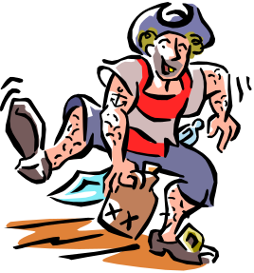

Poem for Two Voices
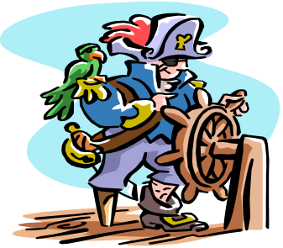

Select two main characters from the book The Not-So-Jolly Roger, such as Blackbeard and Joe or Blackbeard and Sam. Compose a poem for two voices. Think of something that the characters might have different views about. Then, get them to talk to one another. Use the poem by Paul Fleischman or Allan Wolf as a model for your writing. To read Fleischman’s and Wolf’s poems, you need two voices. Lines written across from one another are read together. Although these poems rhyme, yours doesn’t have to. In addition, you are invited to include an artistic representation that symbolizes a theme in your poem.

You may want to write your poem with a partner. You might also want to write a poem for three or even four voices.
Reader’s Theatre
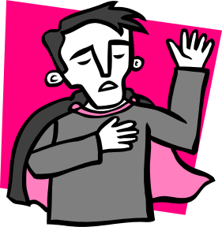


Jon Scieszka reveals the characters in The Not-So-Jolly Roger by how they speak, what they do, and by how they look. The narrator allows for the reader to “hear” the characters’ voices. You are invited to prepare a Reader’s Theatre presentation for a scene from the book. The scene should be no less than 2 pages and no longer than 8 pages. Read Readers on Stage: A Guide to Reader’s Theater (or Readers Theatre) by Aaron Shepard to help you with the process. http://www.aaronshep.com/rt/Tips.html

In one form of Reader’s Theatre, students are assigned to read both the narration and the dialogue in certain sections of a book. A narrator(s) reads the non-dialogue parts. If the non-dialogue parts become long, or are more than one paragraph at a time, there is often more than one narrator. The students sit on stools or chairs in the front of the classroom. No scenery or props are necessary.

The focus is for students to read and re-read the script so that in the end, they will perform the reading with fluency, appropriate prosody (phrasing and expression), and a complete and thorough understanding of the text. Because props are minimal, students read from their scripts, and use their expression, intonation, rate and other prosodic features to convey the meaning of the story to audience members.

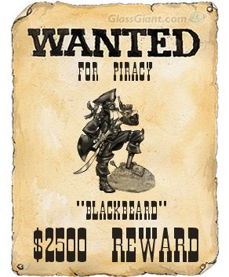

http://www.glassgiant.com/wanted/
Create a Wanted Poster for one of the following characters:
- Blackbeard
- Blackbeard's crew
- Sam
- Fred
- Joe
You will complete an artistic representation of the character and then complete the following information for your character:
Wanted
Character name
Early days
How career began
Place last seen
Physical Description
Hobbies/Interests
Acts
Likes
Dislikes
Hang Outs
Wanted For

Please be sure to make your wanted poster as creative as possible!!!!!

Final Vocabulary Assessment
Multiple Choice: Circle the best answer.
1. If you move or stand unsteadily, this is an example of being :
- Confused
- Staggered
- Balanced
- Unsure
2. If you show great intelligence, talent, and quality, this is an example of being:
- Unable to do something
- Stupid
- Unintelligent
- Brilliant
3. The kidnapper demanded which of following:
- ransom
- jewelry
- food
- nothing at all
4. The building was huge and this would be an example of the building being:
- small
- medium
- monstrous
- big
5. The building has terrible living conditions which is an example of:
- attractive
- great
- horrible
- decent

6. If your brother makes you mad and you hit him he upset you or you would have not hit him, this is an example which vocabulary word:
- You got mad otherwise you wouldn’t have hit your brother.
- Not caring and just hitting your brother because you were mean.
- Planning on hitting your brother anyways.
- Your brother gets on your nerves all the time.
7. If you are speaking in a low grumble or indistinct utterance, you are sounding:
- loud
- muttered
- unsure
- confused
8. When your parents handed you $100.00 for no reason, you were shocked:
- stubborn
- upset
- happy
- stunned
9. If you are in pain from falling off your bike, you are showing it by which of the following:
- groaning
- jumping for joy
- yelling because you are mad
- solemn
10. If you are mad at your parents, this might be the way you talk to them so you won’t get into trouble more:
- yelling
- murmured
- merry
- horribly

Rubric
Activity/Criteria  NOTE: This packet is to be word-processed! | Your points/Total possible points
Packet Cover/Cover Sheet  - Displays thoughtful connection to the book  - Is well designed: interesting and creative format  - Aesthetically appealing  - Items on cover represent symbols, objects, people or places in the book | /5
What I Noticed Areas  - All 3 areas are completed with thoughtful and detailed observations. | /5
KWL  - All portions of the K-W-L chart are completed; thought and effort is demonstrated | /5
Pre-Reading Activity  - Examples are complete; thought and effort is demonstrated | /5
Page for Alphabet Book  - Information is correct and interesting  - Information is organized  - Design is creative and inviting | /5
Character Sketcher  Sketch includes thoughtfully selected information about the character, including 3 implied character traits, problem and solution, and character goal  - Artistic Impression is creative and demonstrates knowledge of information given in text regarding character’s physical description | /5
Discussion Director  - Questions displays insights into novel’s main events and themes; questions are “higher-level”  - Answers are provided and when appropriate, page #’s | /5
Vocabulary Definitions and Activities (Week 1)  - Definitions are “child-friendly”  - Activities are correct and complete | /5
Double-Entry Diary  - Example is well chosen, well explained and thoughtfully crafted  - Provides more than one thoughtful idea/supporting reason | /5
Internet Workshop (1 workshop complete)  - Notes reveal thoughtful preparation for participation;  - Information in graphic organizer, PowerPoint or poem is correct and well organized; main ideas are present.  - Visual representation is present. | /10
Author’s Craft  - Chart includes 2 well-chosen examples of simile and onomatopoeia from the novel  - Explanations are included of how figurative language adds meaning to the text  - Artistic representation is thoughtful and creative | /5
Vocabulary Definitions and Activities (Week 2)  - Definitions are “child-friendly”  Activities are correct and complete | /5
“I Poem”  - Is in the form of an I poem  - Includes thoughtfully chosen words and images to reveal character  - Includes alliteration, simile or metaphor | /5
Feature Story  - Interesting lead grabs the reader  - Concise, organized, and creative story which includes necessary details and reveals understanding of main character’s personality  - Specific examples in text are referenced  - Word choice is thoughtful and demonstrates an understanding of the historic nature of the events as well as free from grammar and spelling errors | /5
Learning Log/ Response Journal  - Answers all questions.  - Gives a thoughtful response and includes a personal experience. | /5

